ESQL_Create_Customer_Account message flow:

The input message to the ESQL_Create_Customer_Account message flow
contains the details of a customer who has registered with the online bookstore
Web site. The customer has provided information such as their name, contact
details, a delivery address, and payment details. Example 4-3 shows the input
message for the ESQL_Create_Customer_Account message flow.

Input Msg :

<Create_Customer_Account_MSG>
<Personal_Details>
<First_Name>Peter</First_Name>
<Last_Name>Smith</Last_Name>
<User_ID>PSmith</User_ID>
<Password>p45sw0rd</Password>
</Personal_Details>
<Email_Address>Peter.Smith@nowhere.com</Email_Address>
<Daytime_Telephone>1234567890</Daytime_Telephone>
<Evening_Telephone>1234567890</Evening_Telephone>
<Shipping_Address>
<Address_1>19 Green Street</Address_1>
<Address_2>Littleton</Address_2>
<Town>Southington</Town>
<Postcode>SU29 8YT</Postcode>
</Shipping_Address>
<Billing_Address>
<Address_1>19 Green Street</Address_1>
<Address_2>Littleton</Address_2>
<Town>Southington</Town>
<Postcode>SU29 8YT</Postcode>
</Billing_Address>
<Payment_Details>
<Card>VISA</Card>
<Card_Number>1234567890</Card_Number>
<Expiry_Date>31.12.2009</Expiry_Date>
<Issue_Date>31.12.2004</Issue_Date>
<Issue_Number>02</Issue_Number>
<Security_Code>333</Security_Code>
</Payment_Details>
</Create_Customer_Account_MSG>

Database :

CREATE DB BSTOREDB
CONNECT TO BSTOREDB
CREATE TABLE BOOKORDRTB (USERID CHAR(15) NOT NULL, ORDERNO VARCHAR(40) NOT NULL, TIMESTAMP CHAR(25) NOT NULL, ISBN CHAR(10) NOT NULL, BOOK_PRICE FLOAT NOT NULL)
DROP TABLE CUSTACCTB
CREATE TABLE CUSTACCTB (LAST_NAME CHAR(20) NOT NULL, FIRST_NAME CHAR(20) NOT NULL, USERID CHAR(15) NOT NULL, PASSWORD CHAR(15) NOT NULL, EMAIL CHAR(25), DAY_PHONE CHAR(15), EVE_PHONE CHAR(15), SHIP_ADDRESS1 CHAR(20), SHIP_ADDRESS2 CHAR(20), SHIP_TOWN CHAR(20), SHIP_POSTCODE CHAR(20), BILL_ADDRESS1 CHAR(20), BILL_ADDRESS2 CHAR(20), BILL_TOWN CHAR(20), BILL_POSTCODE CHAR(20), CARDTYPE CHAR(20), CARDNUM CHAR(30), EXP_DATE DATE, ISS_DATE DATE, ISS_NUM INTEGER, SECCODE INTEGER)
CONNECT RESET
TERMINATE

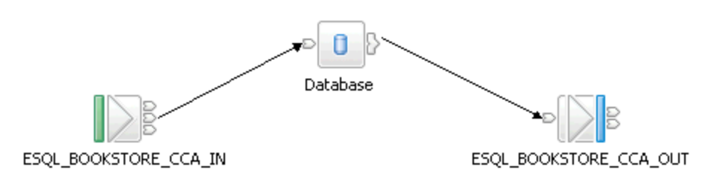

ESQL_Create_Customer_Account message flow:

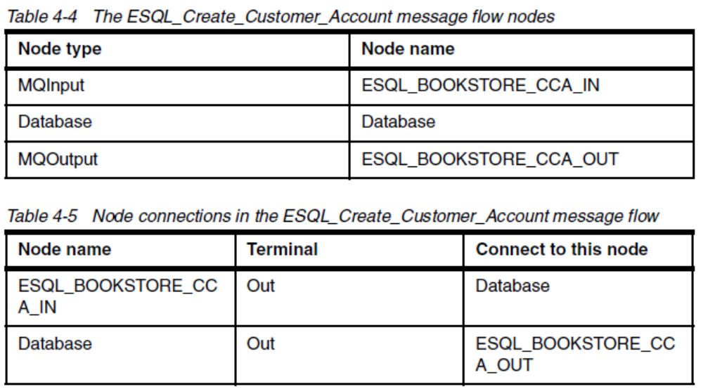

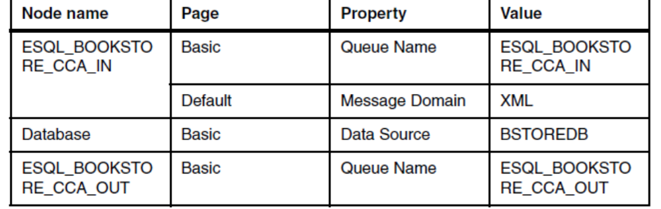

Esql:

CREATE DATABASE MODULE ESQL_Create_Customer_Account_Database
CREATE FUNCTION Main() RETURNS BOOLEAN
BEGIN

INSERT INTO Database.CUSTACCTB(LAST_NAME, FIRST_NAME, USERID, PASSWORD, EMAIL, DAY_PHONE, EVE_PHONE, SHIP_ADDRESS1, SHIP_ADDRESS2, SHIP_TOWN, SHIP_POSTCODE, BILL_ADDRESS1, BILL_ADDRESS2, BILL_TOWN, BILL_POSTCODE, CARDTYPE, CARDNUM, EXP_DATE, ISS_DATE, ISS_NUM, SECCODE)
VALUES(Body.Create_Customer_Account_MSG.Personal_Details.Last_Name,
Body.Create_Customer_Account_MSG.Personal_Details.First_Name,
Body.Create_Customer_Account_MSG.Personal_Details.User_ID,
Body.Create_Customer_Account_MSG.Personal_Details.Password,
Body.Create_Customer_Account_MSG.Email_Address,
Body.Create_Customer_Account_MSG.Daytime_Telephone,
Body.Create_Customer_Account_MSG.Evening_Telephone,
Body.Create_Customer_Account_MSG.Shipping_Address.Address_1,
Body.Create_Customer_Account_MSG.Shipping_Address.Address_2,
Body.Create_Customer_Account_MSG.Shipping_Address.Town,
Body.Create_Customer_Account_MSG.Shipping_Address.Postcode,
Body.Create_Customer_Account_MSG.Billing_Address.Address_1,
Body.Create_Customer_Account_MSG.Billing_Address.Address_2,
Body.Create_Customer_Account_MSG.Billing_Address.Town,
Body.Create_Customer_Account_MSG.Billing_Address.Postcode,
Body.Create_Customer_Account_MSG.Payment_Details.Card,
Body.Create_Customer_Account_MSG.Payment_Details.Card_Number,
Body.Create_Customer_Account_MSG.Payment_Details.Expiry_Date,
Body.Create_Customer_Account_MSG.Payment_Details.Issue_Date,
Body.Create_Customer_Account_MSG.Payment_Details.Issue_Number,
Body.Create_Customer_Account_MSG.Payment_Details.Security_Code);

RETURN TRUE;
END;

END MODULE;

ESQL_Book_Order message flow:

The input message to the ESQL_Book_Order message flow contains an order
from a customer on the online bookstore Web site. The order contains the
customers’ identification and details of the books that they have ordered. When
the message flow processes the message, it creates a confirmation message
that contains details of the order, including a unique order number and the total
price of all the books in the order. Example 4-7 shows the input message for the

ESQL_Book_Order message flow.

Input Msg:

<Create_Book_Order_MSG>
<Customer_ID>0123456789</Customer_ID>
<Order_Date>2005-09-27 12:55:12</Order_Date>
<First_Class>Yes</First_Class>
<Book_Details>
<ISBN>0123456789</ISBN>
<Book_Price>15.99</Book_Price>
<ISBN>1425112342</ISBN>
<Book_Price>7.99</Book_Price>
<ISBN>9736316345</ISBN>
<Book_Price>25.99</Book_Price>
</Book_Details>
</Create_Book_Order_MSG>

Output Msg :

<Book_Order_Response_MSG>
<Customer_ID>0123456789</Customer_ID>
<Order_Number>012345678920050927125512</Order_Number>
<Order_Date>2005-09-27 12:55:12</Order_Date>
<First_Class>Yes</First_Class>
<Book_Details>
<ISBN>0123456789</ISBN>
<Book_Price>15.99</Book_Price>
</Book_Details>
<Book_Details>
<ISBN>1425112342</ISBN>
<Book_Price>7.99</Book_Price>
</Book_Details>
<Book_Details>
<ISBN>9736316345</ISBN>
<Book_Price>25.99</Book_Price>
</Book_Details>
<Delivery_Price>18.00</Delivery_Price>
<Total_Price>49.97</Total_Price>
<Order_Status>Order Received</Order_Status>
</Book_Order_Response_MSG>

ESQL_Book_Order message flow:

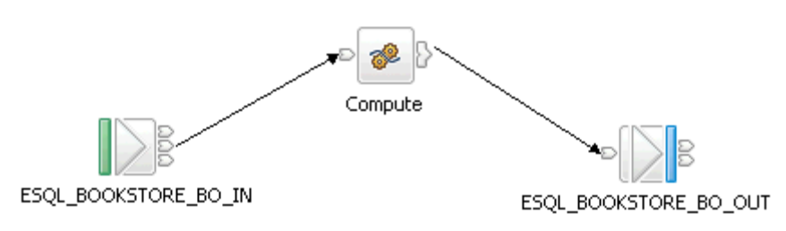

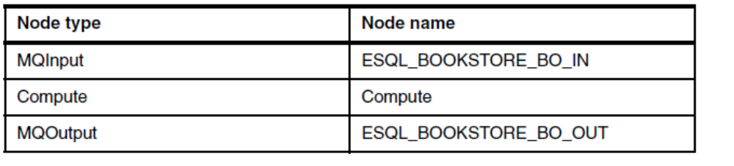
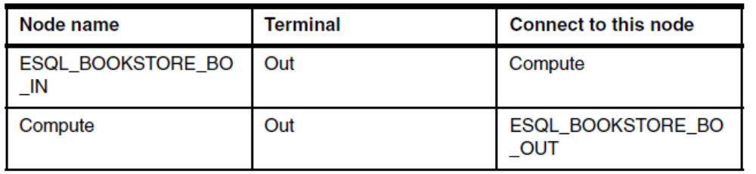

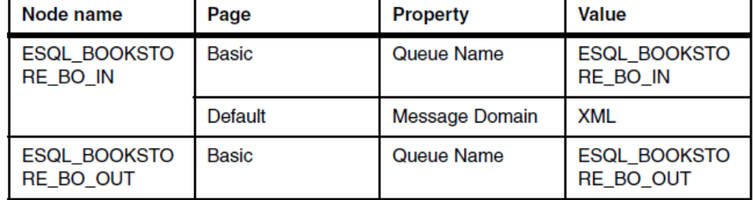

-- (c) Copyright IBM Corp. 2005

CREATE COMPUTE MODULE ESQL_Book_Order_Compute
CREATE FUNCTION Main() RETURNS BOOLEAN
BEGIN
CALL CopyMessageHeaders();
-- SET OutputRoot.XML.Book_Order_Response_MSG = InputRoot.XML.Create_Book_Order_MSG;
SET OutputRoot.XML.Book_Order_Response_MSG.Customer_ID = InputRoot.XML.Create_Book_Order_MSG.Customer_ID;
DECLARE input TIMESTAMP InputRoot.XML.Create_Book_Order_MSG.Order_Date;
DECLARE pattern CHARACTER 'yyyyMMddHHmmss';
DECLARE orderDate CHARACTER CAST(input AS CHARACTER FORMAT pattern);
SET OutputRoot.XML.Book_Order_Response_MSG.Order_Number = InputRoot.XML.Create_Book_Order_MSG.Customer_ID || orderDate;
SET OutputRoot.XML.Book_Order_Response_MSG.Order_Date = InputRoot.XML.Create_Book_Order_MSG.Order_Date;

DECLARE deliveryPrice DECIMAL;
IF InputRoot.XML.Create_Book_Order_MSG.First_Class = 'Yes' THEN
SET OutputRoot.XML.Book_Order_Response_MSG.First_Class = InputRoot.XML.Create_Book_Order_MSG.First_Class;
SET deliveryPrice = 18.00;
END IF;

IF InputRoot.XML.Create_Book_Order_MSG.Second_Class = 'Yes' THEN
SET OutputRoot.XML.Book_Order_Response_MSG.Second_Class = InputRoot.XML.Create_Book_Order_MSG.Second_Class;
SET deliveryPrice = 12.00;
END IF;

IF InputRoot.XML.Create_Book_Order_MSG.Airmail = 'Yes' THEN
SET OutputRoot.XML.Book_Order_Response_MSG.Airmail = InputRoot.XML.Create_Book_Order_MSG.Airmail;
SET deliveryPrice = 8.00;
END IF;

DECLARE bookCount INTEGER;
DECLARE numBooks INTEGER;
DECLARE sumBookPrice DECIMAL 0;
SET bookCount = 1;
SET numBooks = CARDINALITY(InputRoot.XML.Create_Book_Order_MSG.Book_Details.ISBN[]);
WHILE bookCount<= numBooks DO
SET sumBookPrice = sumBookPrice + CAST(InputRoot.XML.Create_Book_Order_MSG.Book_Details.Book_Price[bookCount] AS DECIMAL);
SET OutputRoot.XML.Book_Order_Response_MSG.Book_Details[bookCount].ISBN = InputRoot.XML.Create_Book_Order_MSG.Book_Details.ISBN[bookCount];
SET OutputRoot.XML.Book_Order_Response_MSG.Book_Details[bookCount].Book_Price = InputRoot.XML.Create_Book_Order_MSG.Book_Details.Book_Price[bookCount];
SET bookCount = bookCount + 1;
END WHILE;

SET OutputRoot.XML.Book_Order_Response_MSG.Delivery_Price = deliveryPrice;
SET OutputRoot.XML.Book_Order_Response_MSG.Total_Price = sumBookPrice;
SET OutputRoot.XML.Book_Order_Response_MSG.Order_Status = 'Order Received';
-- CALL CopyEntireMessage();
RETURN TRUE;
END;

CREATE PROCEDURE CopyMessageHeaders() BEGIN
DECLARE I INTEGER;
DECLARE J INTEGER;
SET I = 1;
SET J = CARDINALITY(InputRoot.*[]);
WHILE I < J DO
SET OutputRoot.*[I] = InputRoot.*[I];
SET I = I + 1;
END WHILE;
END;

CREATE PROCEDURE CopyEntireMessage() BEGIN
SET OutputRoot = InputRoot;
END;
END MODULE;

